# Task 4

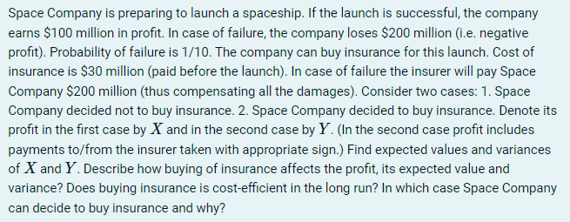

|  |  |  |
| --- | --- | --- |
| $$P$$ | 0.9 | 0.1 |
| $$X$$ | 100 | -200 |
| $$X-EX$$ | 30 | -270 |
| $${\left(X-EX\right)}^{2}$$ | 900 | 72900 |

|  |  |  |
| --- | --- | --- |
|  | 0.9 | 0.1 |
| $$Y$$ | 70 | -30 |
| $$Y-EY$$ | 10 | -90 |
| $${\left(Y-EY\right)}^{2}$$ | 100 | 8100 |

$$EY=Σ_{i=1}^{n}p_{i}y_{i}=0.9⋅70+0.1⋅\left(-30\right)=63-3=60$$

$$Var Y=E{\left(Y-EY\right)}^{2}=Σ_{i=1}^{n}p_{i}{\left(y_{i}-EY\right)}^{2}=0.9⋅100+0.1⋅8100=900$$

As we can see from the calculations, buying insurance decreases expected value of profit and it’s variance. It means that in long run, if no accidents occur, Space Company will get less profit from every launch of a spaceship. So the 1st strategy (without insurance) seems to be more profitable.

At the same time in the long run, the 2nd strategy (with insurance) is safer. It’s fine if Company has a lot of money, then it can cover the cost of a failed launch. But if several launches fail in a row, then there is a high chance that Company will go bankrupt. But if Company has insurance, then failed launches won’t cost as much.

So basically, if the Company is rich enough it might ignore dangers of failed launches and not buy insurance to get more profit. Otherwise, buying insurance can save the company a lot of trouble, especially in case of continuous failures.